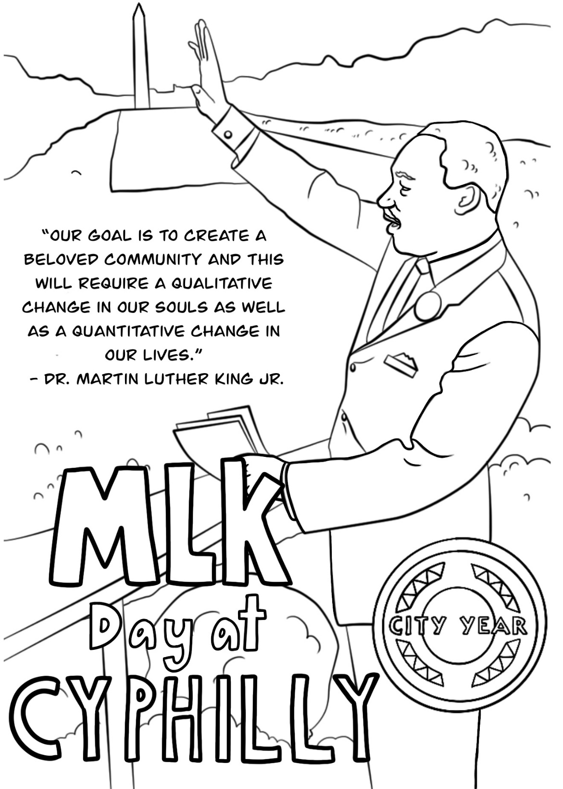
Dear ____________________________,
____________________________________________
____________________________________________
____________________________________________
_____________________________________________________
____________________________________________
____________________________________________
____________________________________________
____________________________________________
____________________________________________
____________________________________________
____________________________________________
____________________________________________
____________________________________________
____________________________________________
____________________________________________
____________________________________________
____________________________________________

Sincerely,

